Wellness Hour
30 Min Guided Workout
Dynamic Warm Up (5 Minutes)
- Arm Circles
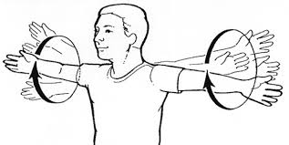
- Modified jumping jacks (A: side steps each leg)
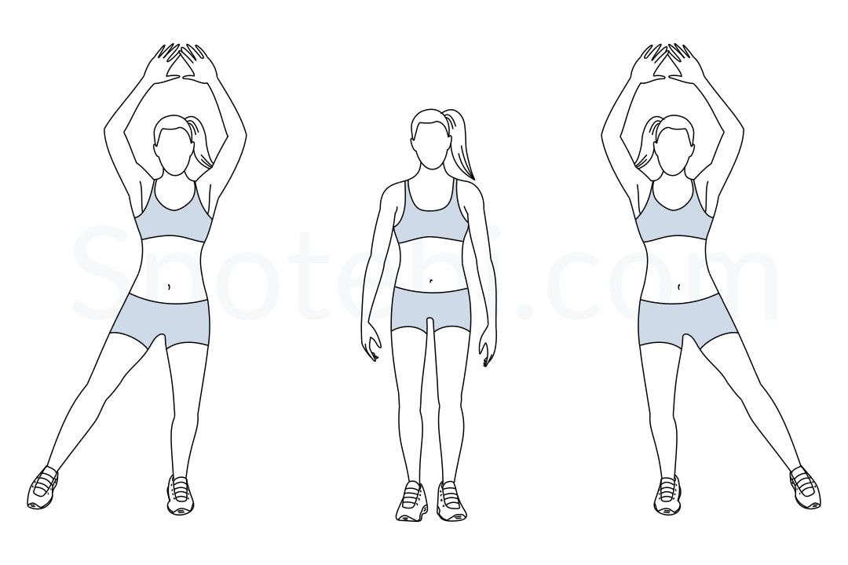
- Hamstring scoops
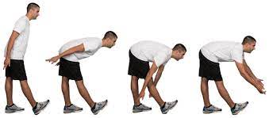
- Warrior #1 pose for quad activation
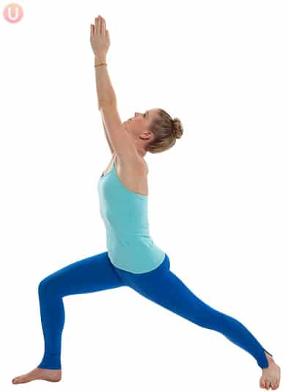

Circuit workout #1 (each exercise 30 seconds on, 30 seconds off, 2x through)
- Exercise #1- arms: Prayer Pulse
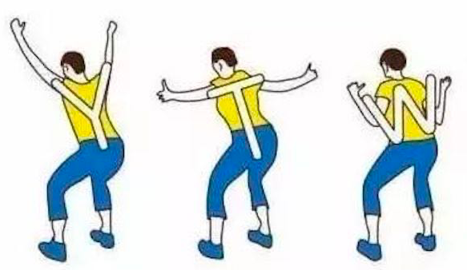
- Exercise #2- bodyweight squats (A: chair sit to squat)
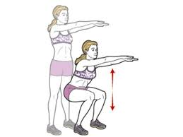
- Exercise #3- Knee to oblique (A: no knee raise, elbows go either side). To make this exercise harder, add a squat in the middle position
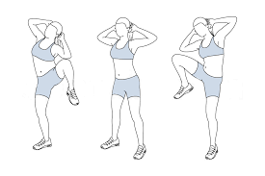
- Exercise #4- standing split leg lunges (lunges without the step back/forward)
- 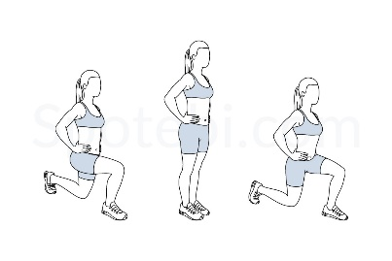
Circuit workout #2 (each exercise 30 seconds on, 30 seconds off, 2x through)
- Exercise #1: Bodyweight march with arm swings (more intense: high knees or jog in place)
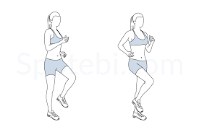
-Exercise #2: Bicep extensions (40 reps)
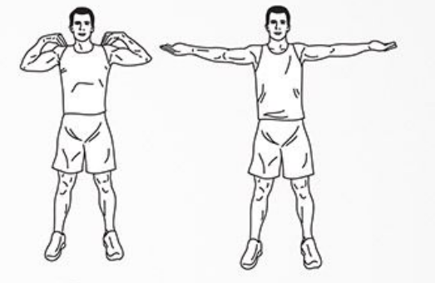
- Exercise #3: Single leg Romanian dead lift, weights optional. (A: hold on to chair for balance)
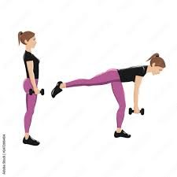
- Exercise #4 :Calf raises 20 each side (A: both feet go up together)
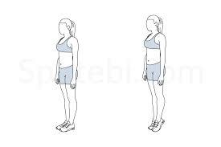

COOL DOWN/BREATH WORK
Cool down stretching: (30 second on, 30 second off x 3)
- Toe reach
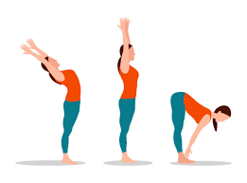
- Rounded back
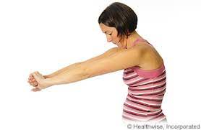
- Cross body shoulder extension
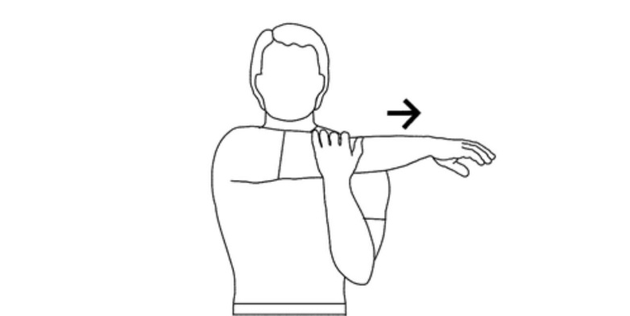
- Standing quadricep stretch (30 seconds each leg) A: hold on to chair for balance
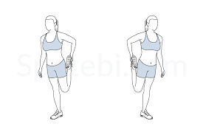
Breath work (5 minutes)
- Find a comfortable position
- Take a moment to notice your thoughts (Where is your mind right now?
- Feel free to close your eyes, soften your graze
- Take a moment to find your breath
- When ready, take 2 deep breaths. Noticing how that feels
- Return to your natural rhythm; where do you feel your breath most
- If your mind starts to wonder; think of this point- your chest, your back, your nostril, your upper lip.
- As you breath in and out; be aware of your breath- in and out. In and out.
- Slowly bring your focus back to where you are. You can begin to open your eyes, move anything that might be feeling tense, wiggle your toes and your fingers and become aware your whole body

STRESS RELIEF: The Physiological Sigh
How: take a deep breath in through your nose, hold it, and try and take an extra inhale in through your nose. Then, slowly exhale ALL the breath out of your nose.

